**DETECTION OF DIABETIC FOOT ULCER**

A PROJECT REPORT

###### ***Submitted by***

###### 

##### MONICA.M [REGISTER NO:211418104159]

##### NAGA SARANYA.K [REGISTER NO:211418104166]

***in partial fulfillment for the award of the degree***

***of***

**BACHELOR OF ENGINEERING**

IN

# COMPUTER SCIENCE AND ENGINEERING



PANIMALAR ENGINEERING COLLEGE

**(An Autonomous Institution, Affiliated to Anna University, Chennai)**

##### MAY 2022

# PANIMALAR ENGINEERING COLLEGE

###### **(An Autonomous Institution, Affiliated to Anna University, Chennai)**

**BONAFIDE CERTIFICATE**

Certified that this project report **“DETECTION OF DIABETIC FOOT ULCER”**

is the bonafide work of “**MONICA.M ( REGISTER NO : 211418104159) AND NAGA SARANYA.K ( REGISTER NO : 211418104166) ”** who carried out the project work under **MRS.V.SATHYA PREIYA** supervision.

**SIGNATURE SIGNATURE**

**Dr.S.MURUGAVALLI,M.E.,Ph.D ., MRS.V.SATHYA PREIYA**

**HEAD OF THE DEPARTMENT SUPERVISOR**

DEPARTMENT OF CSE, DEPARTMENT OF CSE,

PANIMALAR ENGINEERING COLLEGE, PANIMALAR ENGINEERING COLLEGE,

NASARATHPETTAI, NASARATHPETTAI,

POONAMALLEE, POONAMALLEE,

CHENNAI-600 123. CHENNAI-600 123.

Certified that the above mentioned students were examined in the End Semester project Viva-Voice held on...........................

**INTERNAL EXAMINER EXTERNAL EXAMINER**

**DECLARATION BY THE STUDENT**

We **MONICA.M (REGISTER NO : 211418104159) and NAGA SARANYA.K (REGISTER NO : 211418104166)** hereby declare that this project report titled **“DETECTION OF DIABETIC FOOT ULCER”,** under the guidance of **MRS.V.SATHYA PREIYA** is the original work done by us and we have not plagiarized or submitted to any other degree in any university by us.

**ACKNOWLEDGEMENT**

We would like to express our deep gratitude to our respected Secretary and Correspondent **Dr.P.CHINNADURAI, M.A., Ph.D.** for his kind words and enthusiastic motivation, which inspired us a lot in completing this project.

We express our sincere thanks to our Directors **Tmt.C.VIJAYARAJESWARI**, **Dr.C.SAKTHI KUMAR,M.E.,Ph.D** and **Dr.SARANYASREE SAKTHI KUMAR B.E.,M.B.A.,Ph.D.,** for providing us with the necessary facilities to undertake this project.

We also express our gratitude to our Principal **Dr.K.Mani, M.E., Ph.D.** who facilitated us in completing the project.

We thank the Head of the CSE Department, **Dr. S.MURUGAVALLI , M.E.,Ph.D.,** for the support extended throughout the project.

We would like to thank my **MRS.SATHYA PREIYA.V** and all the faculty members of the Department of CSE for their advice and encouragement for the successful completion of the project.

**MONICA.M**

**NAGA SARANYA.K**

**ABSTRACT**

Worldwide, 1 person in 11 has diabetes mellitus. Diabetic Foot Ulcers (DFU) is a major complication of the diabetic disease, which, if not treated properly, can lead to severe effect of amputation. It is usually the result of poor glycaemic control, underlying neuropathy, peripheral vascular disease, or poor foot care. It is also one of the common causes for osteomyelitis of the foot and amputation of lower extremities. These ulcers are usually in the areas of the foot which encounters repetitive trauma and pressure sensations. Staphylococcus is the common infective organism.

Current therapies in DFU treatment depend on patient and physician monitoring, with important limitations such as the high costs involved in diagnosing, treating, and long-term care of DFU. We have compiled a comprehensive database of foot images, which contain DFU for different patients. Diabetic foot ulcers are responsible for more admissions than any other diabetic complication. Educating the patient about the complication and the need for proper medical care will reduce the risk of complications and good compliance.

In this paper, we have proposed the use of traditional computer diagnostic features for foot ulcers among diabetic patients, representing a cost-effective, remote and simple healthcare solution. In this DFU classification problem, we examined two categories such as normal skin (healthy skin) and abnormal skin (DFU). In addition, we used Convolutional Neural Networks in the DFU division. We have developed a novel neural convolutional network design, DFUNet, with the best extraction feature to highlight the characteristic difference between healthy skin and DFU. This works best for both machine learning and the deep learning stages we have explored. Here we present the development of the novel with the most critical DFUNet for accurately detecting the presence of DFUs. This novel approach has the potential to bring about a paradigm shift in the care of diabetic feet.

TABLE OF CONTENTS

| **CHAPTER NO.** | **TITLE** | **PAGE NO.** |
| --- | --- | --- |
|  | **ABSTRACT** | i |
|  | **LIST OF TABLES** | vi |
|  | **LIST OF FIGURES** | v |
|  | **LIST OF SYMBOLS, ABBREVIATIONS** | vi |
| **1.** | **INTRODUCTION** |  |
|  | 1.1 Problem Definition | 1 |
| **2.** | **LITERATURE SURVEY** | 3 |
| **3.** | **SYSTEM ANALYSIS** |  |
|  | 2.1 Existing System | 7 |
|  | 2.2 Proposed system | 8 |
|  | 2.3 Feasibility Study | 9 |
|  | 2.4 Hardware Environment | 10 |
|  | 2.5 Software Environment | 10 |
| **4.** | **SYSTEM DESIGN** |  |
|  | 4.1. ER diagram | 11 |
|  | 4.2. UML Diagrams | 12 |
|  | 4.3. Architecture Diagram | 15 |
| **5.** | **SYSTEM ARCHITECTURE** |  |
|  | 5.1 Module Design Specification | 16 |
|  | 5.2 Algorithms | 19 |
| **6.** | **SYSTEM IMPLEMENTATION** |  |
|  | 6.1 Coding | 22 |
| **7.** | **SYSTEM TESTING**  **PERFORMANCE ANALYSIS** |  |
|  | 7.1 Unit Testing | 28 |
|  | 7.2 Integration Testing | 28 |
|  | 7.3 Test Cases & Reports | 29 |
| **8.** | **CONCLUSION** |  |
|  | 8.1 Conclusion and Future Enhancements | 32 |
| **9.** | **APPENDICES** |  |
|  | 9.1 Sample Screens | 33 |
|  | 9.2 Publications |  |
|  | **REFERENCES** | 38 |

LIST OF TABLES

| **CHAPTER NO.** | **TITLE** | **PAGE NO.** |
| --- | --- | --- |
| 7.4.1. | Test Case table of home page for Diabetic Foot Ulcer | 30 |
| 7.4.2. | Test Case table for Result of Detection page for Diabetic Foot Ulcer | 31 |

LIST OF FIGURES

| **CHAPTER NO.** | **TITLE** | **PAGE NO.** |
| --- | --- | --- |
| 4.1.1. | ER Diagram for Diabetic Foot Ulcer | 11 |
| 4.2.1.1. | Use case Diagram for Diabetic Foot Ulcer | 12 |
| 4.2.2.1. | Activity Diagram for Diabetic Foot Ulcer | 13 |
| 4.2.3.1 | Sequence Diagram for Diabetic Foot Ulcer | 14 |
| 4.3.1 | Architecture Diagram for Diabetic Foot Ulcer | 15 |
| 5.1.1. | System Design for Diabetic Foot Ulcer | 18 |
| 5.2.1. | An overview of Convolutional Architecture for Diabetic Foot Ulcer | 20 |
| 5.2.2. | Pooling Example for Diabetic Foot Ulcer | 21 |
| 8.2.1. | Anaconda Prompt | 33 |
| 8.2.2. | Idle Shell | 33 |
| 8.2.3. | DFU Home Page | 34 |
| 8.2.4. | Test images | 34 |
| 8.2.5. | Result of DFU Detection (Healthy Skin) | 35 |
| 8.2.6. | Result of DFU Detection (Diabetic Foot Ulcer Skin) |  |
| 8.2.7. | Accuracy Calculation | 35 |
| 8.2.8. | Jupyter Notebook Files | 36 |
| 8.2.9. | Training code | 36 |

**LIST OF ABBREVIATIONS**

DFU – Diabetic Foot Ulcer

CNN – Convolution Neural Network

ADA – American Diabetes Association

RCT – Randomized Controlled Trials

ECM – Extracellular Matrix

MMP – Matrix Metalloproteinase

TGF – Tumor Growth Factor

VEGF – Vascular Endothelial Growth Factor

DR – Diabetic Retinopathy

ERD – Entity Relationship Diagram

UML – Unified Model Language

ROI – Region Of Interest

ReLU – Rectified Linear Unit

LRN – Local Response Normalisation

**CHAPTER 1**

**INTRODUCTION**

**1.1. PROBLEM DEFINITION**

With an estimated 34% of life-threatening risk occuring due to foot ulcers (DFU), is one of the most common complications in diabetic patients. These wounds are associated with significant illness and death as they can lead to life-threatening complications, such as infection and amputation of the lower limbs. DFU represents a complex business that is the result of a number of contributing factors including neuropathy, cardiovascular disease, and metabolic derangement, which can occur alone or at any concert. Due to a variety of pathological processes, the DFU management requires a multimodal and interdisciplinary approach that should include (1) prevention, (2) identification of various mechanisms that contribute to its formation, and (3) promoting wound healing. The current pillar of DFU management includes prevention with standard wound care principles. Therefore, there is a need for new therapies targeted at all aspects of DFU wound care, which includes wound prevention and promoting wound healing in their formation. Combined therapies are often indicated when DFU has failed SOC and may be a new goal at DFU care level. However, many of these treatments are expensive, and little is known about their true clinical success. In this review, we aim to re-evaluate the extent to which DFU care requires a comprehensive approach, which includes treatment targeted at a variety of DFU etiologies and promotes wound healing. We are also reviewing the latest trends in DFU management.

Prevention begins with proper testing in diabetic patients. The American Diabetes Association (ADA) recommends an annual diagnosis of neuropathy, starting with the diagnosis of type 2 diabetes and 5 years after the diagnosis of type 1 diabetes. The neuropathy test should include a careful history, which confirms that you inquire about the symptoms of paraesthesia, burning, and diminished or absent sensation. Each patient should also undergo a neurological examination using a 10-g monofilament test to detect the loss of protective hearing and to identify individual risk of injury and amputation. Additional tests may include temperature sensing and pinprick as well as vibration tests. Suitable footwear includes shoes made of forgiving materials (e.g., leather) and that can carry foot deformities and edema. Proper footwear can relieve pressure points; to reduce shock, shear stress, and the formation of calluses. More importantly, it has been shown to prevent DFU. Improperly worn shoes, those that are over-worn, or that cause itching, erythema, blisters, or calluses should be avoided. As there are many basic factors that influence DFU, changing risk factors is also a key factor in prevention. Strict glycemic control has been shown to effectively delay or prevent diabetic neuropathy. However, strict glucose control in patients with DFU may have little effect on ischemia; therefore patients should try to reverse other risk factors for ischemia, such as atherosclerosis. These may include severe ischemic remodeling, weight loss, smoking cessation, and reduced alcohol intake. Patients may also consider leg height and stock pressure to reduce edema in the event of venous deficiency. Finally, calluses are major risk factors for ulcers, as they increase plant stress, leading to tissue rupture. Therefore, regular removal of callus is recommended. Although it is well known that adequate nutrition is important in wound healing and that metabolic imbalances contribute to the development of DFU, the role of nutrition and supplementation in DFU prevention is unclear.

Malnutrition is common in DFU patients, but there is little conclusive evidence that better nutrition or support will improve wound healing or prevent DFU in the first place. Most studies on nutrition and DFU are not Randomized Controlled Trials (RCTs), often have a variety of variable results, and do not provide clear longitudinal and clinical data. For example, recent RCTs studying the effect of vitamin D, vitamin E, and magnesium supplementation on DFU found reduced lesion size, but did not actually report complete wound healing. These may be some of the reasons why the ADA does not directly encourage nutritional support in the management of diabetic foot care.

**CHAPTER 2**

**LITERATURE SURVEY**

**[1] Matilde Monteiro-Soares, Edward J. Boyko et.al “Diabetic foot ulcer classifications: A critical review” Wiley Online Library 16 March 2020**

The purpose of this study was to evaluate published system(s) for diabetic foot ulcers (DFUs) to determine which ones should be recommended for a given clinical purpose. Published sections were to be confirmed for more than 75% of people with diabetes and foot ulcers. Each study was evaluated for internal and external validity and reliability. Eight key factors associated with healing failure were identified in a large series of clinics and each classification was identified by a number of key factors. The categories were then organized according to their proposed purpose into one or more groups: (a) the interaction between care professionals, (b) predicting the clinical outcome of individual lesions, (c) assisting in clinical management decisions for each case, and (d) research to compared the results of indifferent people. The clinical outcomes were not the same but included life without ulcers, wound healing, hospitalization, amputation, death, and costs. Despite the limitations, there has been sufficient evidence to recommend the use of certain categories of indicators listed above.

**[2] Mayland Chang and Trung T. Nguyen “Strategy for Treatment of Infected Diabetic Foot Ulcers” 2021 American Chemical Society**

Diabetic foot ulcers (DFUs) are chronic wounds in about 30% of diabetic patients. In DFUs, the normal wound healing process involving inflammation, angiogenesis, and reorganization of the extracellular matrix (ECM) is disrupted and stopped. Upon injury, neutrophils and monocytes reach the wound and release matrix metalloproteinase (MMP) -8 and active oxygen (ROS) types. ROS activates the nuclear factor kappa beta (NF-κB), which regulates MMP-9. Monocytes become macrophages, producing tumor growth factor (TGF) -β1 and vascular endothelial growth factor (VEGF) for angiogenesis, leading to ECM reuptake. MMP-9 breaks down lamin for keratinocyte to migrate. MMP-8 has benefits in rehabilitating ECM and wound healing. In DFUs, uncontrolled MMP-9 is dangerous, destroys ECM and prevents the wound from healing. DFUs are usually contagious, many of which contain biofilm-resistant viruses that are resistant to antibiotics. The infection increases the healing time of the wound and the chances of amputation. In addition to the use of antibiotics, amputation occurs in 24.5% of patients with DFU.

**[3] Moi Hoon Yap a , Ryo Hachiuma et.al “Deep learning in diabetic foot ulcers detection: A comprehensive evaluation” Computers in Biology and Medicine (2021)**

This paper summarizes the results of DFUC2020 by making comparisons between the deep learning-based algorithms proposed by the winning teams: Faster R – CNN, three versions of Faster R – CNN and the integration method; YOLOv3; YOLOv5; Successful Det; and the new Cascade Attention network. For each in-depth study method, they provide a detailed description of the model structures, training parameter settings and additional categories including pre-processing, data enhancement and post-processing. We provide a complete overview of each method. All methods required a data addition phase to increase the number of images available for training and the post-processing stage to remove false points. Excellent performance was obtained from Deformable Convolution, a variant of Faster R – CNN, with a median accuracy (MAP) of 0.6340 and a F1-Score of 0.6834. Finally, we show that integration based on different in-depth learning methods can improve F1-Score but not MAP.

**[4] Danielle Dixon, Michael Edmonds et.al “Managing Diabetic Foot Ulcers: Pharmacotherapy for Wound Healing” Springer Nature Switzerland AG 2020**

This article highlights the trials, and describes the current medical management of diabetic foot ulcers and the progress made in wound treatment to date. Provides a review of topical and systemic therapies currently in use and those that are being developed for future use in the management of diabetic foot disease. For each treatment, the proposed methods and available evidence to support their clinical use are presented. Growth factors, bio-engineered tissue, stem cell therapy, gene therapy and peptide therapy also have some supporting evidence for the treatment of foot ulcers in diabetes. Non-surgical contaminant agents may be helpful if effective detoxification is not possible, and immune modulators may be helpful in their antimicrobial effects, but strong data is still needed to strengthen the case for normal use. Reviews do not include antimicrobials as their main role is anti-invective and not in wound healing. The development of nanotechnology has made it possible to extend the bioavailability of targeted molecules to the wound site, through the use of glass / hydrogel nanoparticles, polyethylene glycol and hyaluronic acid. Looking ahead, newborn treatments, which include high-energy loads, local delivery of less disruptive RNA and ultimately hydrogels include bioactive agents or cells that may provide potential pharmacies in the future.

**[5] Dragos Serban, MD, PhD1, Nikolaos Papanas, MD, PhD et.al “Diabetic Retinopathy in Patients With Diabetic Foot Ulcer: A Systematic Review” The International Journal of Lower Extremity Wounds 2020**

This review discusses the evidence for diabetic retinopathy (DR) in patients with diabetistic foot ulceration (DFU). Formal literature reviews were conducted at PubMed, Medline, Springer Nature, and Scopus, following the PRISMA guidelines, using the following terms, individually or collectively: "diabetic foot" OR "diabetic" or "DFU" and "Diabetes Retinopathy Diabetes. An initial search revealed 648 articles published between 1975 and 2020. After applying the terms of publication and submission, a total of 9 articles were analyzed, examining the relationship between DR and In all cases, DR and proliferative retinopathy of diabetes were significantly higher before DFU, although the frequency of DR showed greater variability (22.5% to 60.6%). and increased frequency of DR and proliferative diabetic retinopathy. On the other hand, there is a risk of accelerating the progression of DR in DFU is non-healing, which may be related to chronic inflammation and related infections. Therefore, patients with DFU should be monitored by an optometrist, and those with DR should be referred immediately to a specialist diabetic foot clinic.

**[6] Morica M. Tran and Melanie N. Haley “Does exercise improve healing of diabetic foot ulcers? A systematic review” Journal of Foot and Ankle Research (2021)**

This systematic review found there is insufficient evidence to conclusively support non-weight bearing exercise as an intervention to improve healing of diabetic foot ulcers. Regardless, the results demonstrate some degree of wound size reduction and there were no negative consequences of the intervention for the participants. Given the potential benefits of exercise on patient health and wellbeing, non-weight bearing exercise should be encouraged as part of the management plan for treatment of diabetic foot ulcers. Further research is required to better understand the relationship between exercise and healing of diabetic foot ulcers.

**CHAPTER 3**

**SYSTEM ANALYSIS**

**3.1.EXISTING SYSTEM**

The proliferation of information and communication technologies poses both challenges and opportunities regarding the development of modern health care systems.

There are many telemedicine programs under construction right now

a) improve current health care systems and reduce the cost of medical facilities;

b) improve access to medical facilities that is a continuous remote examination of patients with the help of communication equipment;

c) provide automated solutions to address the shortage of medical professionals for these chronic diseases.

Over the years, researchers and doctors have developed important telemedicine programs to monitor diabetes. However, there are very few smart programs designed for diabetic foot tests that can be broken down into non-automated and automated telemedicine programs.

Now-a-days, a smart-size mobile phone with an advanced mobile app has the power of a personal computer capable of capturing and sending high-resolution images and audio and video communication with the help of advanced mobile internet such as 4G. In the non-automated phase, conventional telemedicine systems based on these devices are usually set up at a distance to be monitored by patients. Although these programs provide promising results, there is an urgent need for smart systems that can automatically detect various DFU infections from a distance.

**3.2.PROPOSED SYSTEM**

To compare with traditional features, the deep learning, especially the convolutional neural networks, have been used to distinguish between healthy foot skin and diabetic skin ulcer skin. To improve the release of key DFU segmentation features, we propose a Convolutional Neural Network that uses multiple convolution layers and pooling layers to extract multiple features from the same input. Healthy skin tends to have a smoother texture and DFU has many different features including large edges, strong changes in color as well as rapid changes between healthy skin around it. This proposed system classifies the Diabetic foot ulcer images based on the Features of input image. The major challenges that are involved with this classification task are as follows:

1) large time in collection and expert labelling of the DFU images

2) high inter-class similarity between the normal and abnormal classes of skin lesion and intraclass variations depending upon the classification of DFU, lighting conditions and patient’s ethnicity.

In this work, we have tested a number of Conventional Machine Learning (CML) methods and Convolutional Neural Networks (CNNs) for the classification of ulcer and non-ulcer to improve the feature extraction that can clearly detect the changes in skin texture and color in ulcer and healthy skin with the help of parallel convolution layers that extract multiple-features from the same input and perform faster with the help of fine-tuning and with more accuracy and sensitivity than the other popular systems.

**Advantages of Proposed System**

* CNN's biggest advantage compared to its predecessor is that it automatically detects important features without being monitored.
* CNN also works well with efficiency.
* Uses special convolution and the pooling functions and performs parameter sharing. This allows CNN models to work on any device, making them attractive worldwide.

**3.3. FEASIBILITY STUDY**

The feasibility of a project is assessed at this stage and the business proposal is made with the most common project plan and specific cost estimates. In order to analyze the feasibility, some understanding of the major system requirements is essential.

Three key factors involved in possible analysis are:

* Economic Feasibility
* Technical Feasibility
* Operational Feasibility.

**ECONOMIC FEASIBILITY**

This study is designed to assess the economic impact of the project. The amount of fund that the company can pour into the research and development of the system is limited. The expenditures must be justified. The main purpose of this project is to provide an affordable solution for people suffering from foot ulcers. In this way the plan is developed within the budget as well. It is possible that even poor people can use it properly. Thus the developed system as well within the budget and this was achieved because most of the technologies used are freely available. Only the customized products have to be purchased.

**TECHNICAL FEASIBILITY**

Any system developed must not have a high demand on the available technical resources. This will lead to high demands being placed on the client. This is associated with the complexity of system technology. In this project, we use Convolution Neural Networks which provides a high level of success in diagnosing various diseases. It takes an image as an input and passes convolutions to remove unwanted features and to extract many essential features from the image.

**OPERATIONAL FEASIBILITY**

This includes the process of training the user to use the system correctly. The user should not feel threatened by the system, but should accept it as a necessity. This system will be easy to use and produce a high level of accuracy compared to the existing system.

**3.4.HARDWARE ENVIRONMENT**

Device : Laptop / Desktop

Processor : Pentium Dual Core 2.00 GHZ

Mouse : Wired or Wireless

Hard Disk : 120GB

RAM : 2 GB (Minimum)

Keyboard : 110 Keys enhanced

**3.5.SOFTWARE ENVIRONMENT**

Operating System : Windows 7 and more

IDE : Anaconda

Language : Python

**CHAPTER 4**

**SYSTEM DESIGN**

**4.1. ER DIAGRAM**

The ER represents Entity Relationships Diagrams. The Entity Relationship Diagram (ERD) is a visual representation of the various organizations within the system and how they relate to each other. They are widely used to design database relationships. Businesses in the schema turn into tables, attributes and modify the schema of the website. These are used during the planning stages of software projects.

**Foot ulcer Dataset**

**Figure.4.1.1. ER Diagram for Diabetic Foot Ulcer**

**4.2. UML DIAGRAMS**

Unified Model Language [UML] is a common modeling language. The main purpose of the UML is to explain the general way in which the system is designed. It is exactly the same as the plans/blueprints used in other engineering fields.

**4.2.1. USE CASE DIAGRAMS**

Use case diagrams are a set of use case, actors, and their relationships. It is used to describe the relationship between performance and their internal / external controls. These controls are known as actors.

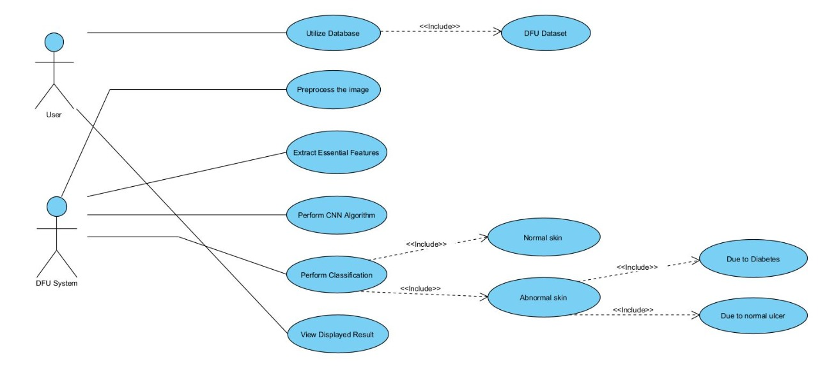

**Figure.4.2.1.1. Use case Diagram for Diabetic Foot Ulcer**

**4.2.2. ACTIVITY DIAGRAM**

An Activity diagram describes the flow of control in a system. Contains activities and links. The flow can be sequentially, parallel, or branches. Tasks are nothing but program functions. Activity diagrams are used to visualize the movement of controls in a system.

The main purpose of Activity Diagram is to show the business and software processes as a progression of actions. These actions can be carried out by people, software components or computers.

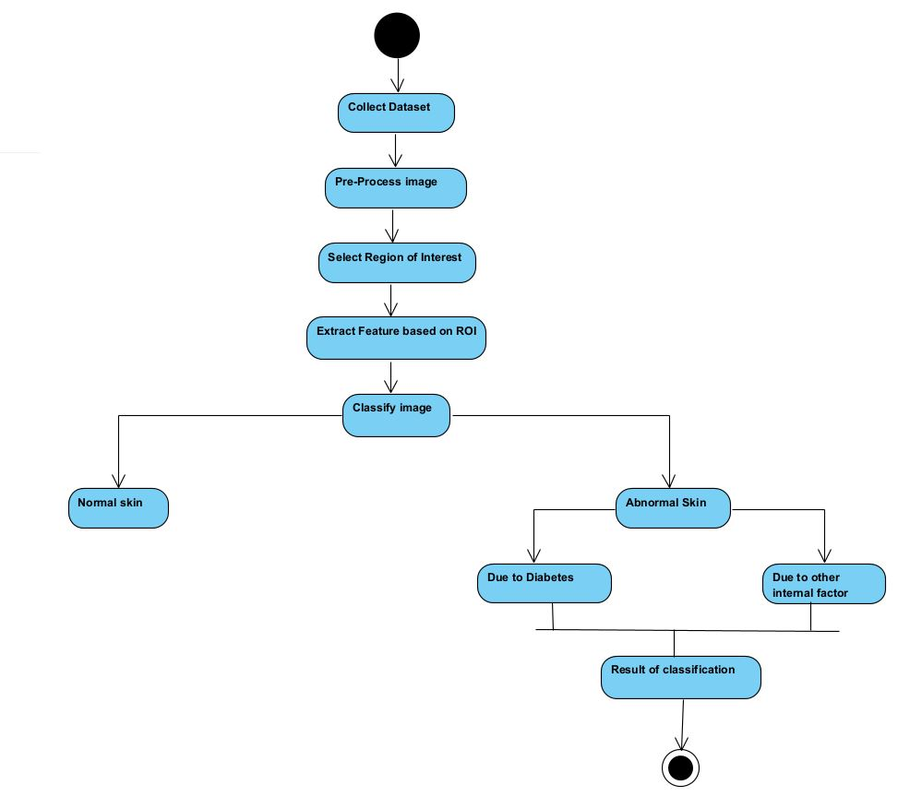

**Figure.4.2.2.1. Activity Diagram for Diabetic Foot Ulcer**

**4.2.3. SEQUENCE DIAGRAM**

Sequential diagram is a diagram of interaction. From the word, it is clear that the diagrams are based on the sequence of events, that is, the sequence of messages that flow from one object to another. Since visualizing the interactions in a system can be a cumbersome task, we use sequence diagram to capture the various features and aspects of interaction in a system.

Here the sequence of events that are happening between the objects is depicted in a sequential manner (i.e) a sequence of messages are being passed between the objects.

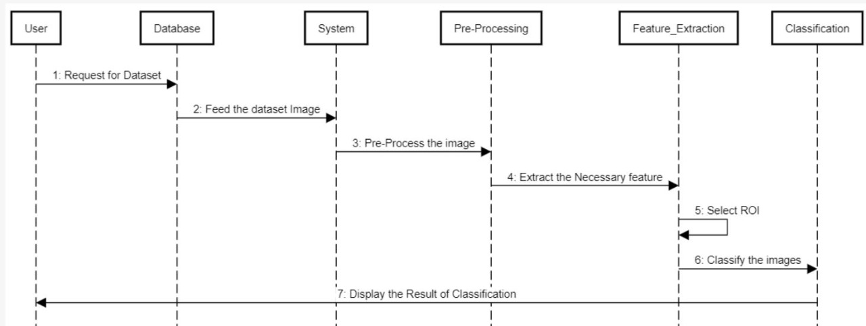

**Figure.4.2.3.1. Sequence Diagram for Diabetic Foot Ulcer**

**4.3. ARCHITECTURE DIAGRAM**

Architectural diagram is a system diagram used to extract the overall structure of a software system and the relationships, boundaries, and boundaries between components. It is a visual representation that maps out the physical implementation for components of a software system.

It offers a top-down view of a process or a system, which makes it easier to get a clear idea about the system.

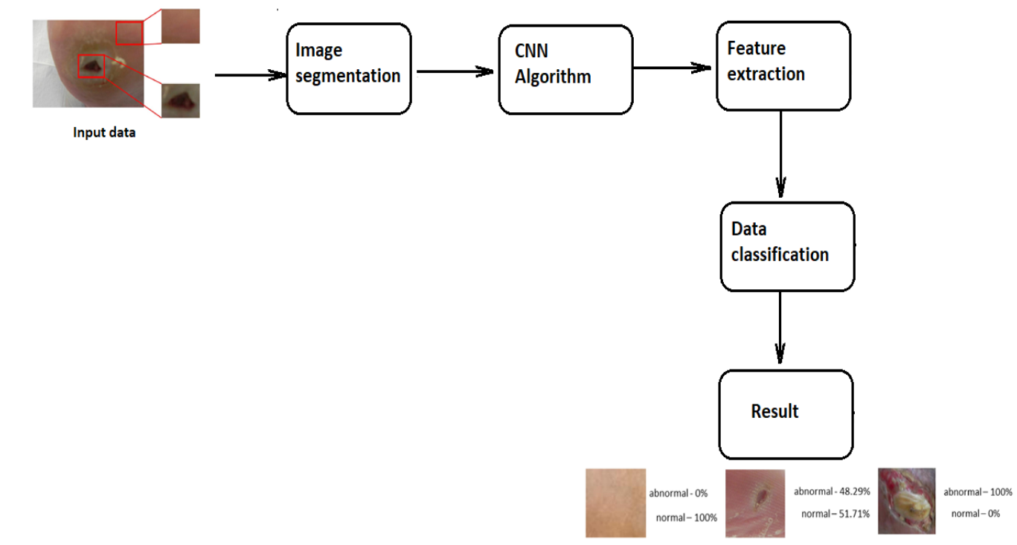

**Figure.4.3.1. Architecture Diagram for Diabetic Foot Ulcer**

**CHAPTER 5**

**SYSTEM ARCHITECTURE**

**5.1. MODULES**

This system consists of the following modules:

* Dataset Collection
* Image Pre-Processing
* Feature Extraction
* Region of Interest
* Classification

**A) Dataset Collection**

A collection of specific high-quality medical metaphors known as the catalog is a necessary tool for consistency testing and comparison of medical image processing algorithms. The database of foot ulcers represents general and diabetic images that are affected by the patient's foot pictures and that are professionally verified.

**B) Image Pre-Processing**

Pre-image processing is the step that is taken to format images before they are used in modeling training and description. This includes, but is not limited to, changing the size, shape, and color correction. It also includes many techniques such as part of gravy, noise removal, and enhancing contrast.

**C) Feature Extraction**

Features Background of an Image contains a lot of information, only some of this information can be used to differentiate between different situations. Most of the information in the image should be converted to a reduced representation set called “Feature Extraction”. An image has many elements such as texture, color, and shape. These features can be used as a small representation of useful information in the image that can be used to distinguish between different contexts. In this study, a variety of texture and color elements were used to identify the foot wound in the images.

**D) Region of Interest**

It is a translation of the "relevant measurement range". The term is used to refer to the appropriate category of measurement curve. This area can be considered statistically best. Based on the area of ​​interest (ROI) you can calculate, for example, the maximum value, the scale and the width of the height, and the area under the curve. Measurement curves recorded can be, for example, calculated values ​​(number per unit of time) registered in appearance, time or near trajectory.

About the region of interest (ROI) as two or three dimensions are common in computer-controlled image processing and photography processes. In the worst cases, for a long time there is even a four-sided view. The region of interest is often used for medical purposes, especially in nuclear medicine. In this case the ROIs are multidimensional.

In the automated ROI test software slightly supports the user to find out which area is questionable. User specifies only the cut-off section that continues and is completed by the testing software. With this type of acquisition, the user can establish approximately where the test software should work.

The region of interest (ROI) is the part of the image that you want to filter or work on in some way. You can represent ROI as a picture of a binary mask. In mask image, the ROI pixels are set to 1 and the external ROI pixels are set to 0. The toolbox offers a few options for specifying ROI and creating a binary mask. The toolbox supports a set of tools that you can use to create multi-dimensional ROIs, such circles, ellipses, polygons, rectangles, and hand-drawn shapes. Once you have created the material, you can adjust its shape, its shape, its appearance, and its behavior.

ROI (Region-of-interest) rendering of dermatosis images can be used to restore image-based imagery. The separation of the image plays an important part in it. And the performance of the segmentation algorithm directly affects the efficiency of the ROI domain.

**E) Classification**

Image separation is where a computer can analyze an image and identify the 'category' the image falls under. According to the extracted feature, the System diagnoses Foot ulcer caused by Diabetics or other diseases.

**CNN Algorithm**

**Dataset Collection**

**Image Pre-Processing**

**Classification of Foot Ulcer**

**Feature Extraction**

**Figure.5.1.1 System Design for Diabetic Foot Ulcer**

**5.2. ALGORITHM**

In order to improve the extracted important features for Diabetic Foot Ulcer Classification, we have proposed a system architecture which makes use of the Convolution Neural Network Architecture (i.e) deep and parallel convolution layer. At the beginning the system makes use of the traditional convolution layers which is nothing but the single convolution filter which is then followed by the parallel convolution layers for extracting a large number of features from the mage given as the input. Identifying changes in healthy skin are a clear problem of computer vision like dangerous skin lesions, so DFUNet was built about convolutions in finding discriminatory features in learning.

Healthy skin often shows a smooth texture and DFU has it many different features including large edges, dynamic changes with intensity or color and rapid changes in the environment healthy skin and the wound itself.

Here each image is trained with 30 Epochs for the accurate extraction of features from the images provided.

**1) Input Data:**

DFU training and validation images are inputs such as 256 × 256 pads from areas containing feet diabetic ulcers and healthy skin. Doing this step again ensures that the image size of the raw material exists reduced before proceeding to the following layers.

**2) Similar Conversion:**

Traditional conversion categories use only one popular convolution filter type from 1 × 1 to 5 × 5 in input data. Each convolution the filter provides a separate feature for the same input. The concept of using a parallel convolution layer states basically a combination of convolution filter input allowing the extraction of a multi-level feature and covering more spreads the collections by inserting the same.

Three sizes convolution kernels are applied to the same convolutional DFUNet layers across: 5 × 5, 3 × 3 and 1 × 1. These are processed in terms of each other and finally integrated. Each convolution provides additional discriminatory power. Low performance is present in the healthy skin samples due to the absence of skin deformities. High performance are present on the diabetic foot ulcer skin due to abnormal skin. Each convolution layer uses a Rectified Linear Unit (ReLU) described as

f (x) = maximum (0, x)

where the function holds the threshold of zero. As we use ReLU for each convolution, including unlimited activation, so we use local response normalization (LRN) to activate this function after each combination of layers of convolution. To avoid the over-fitting problem that occurs in most of the CNN methods, we use,

Let a(i/x,y) be the source output kernel at point (x,y) and b(i/x,y) be the regularized output of point (x,y).

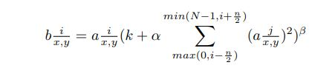

where N is the no.of.kernels and α,β,k,n are parameters.

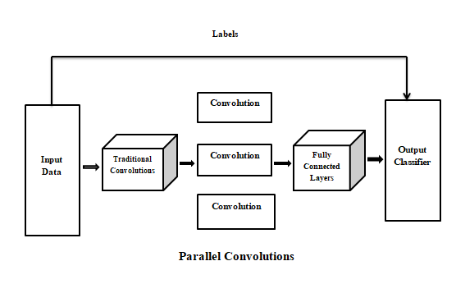

**Figure.5.2.1. An overview of Convolutional Architecture for Diabetic Foot Ulcer**

**3) Fully Connected Layer and Output Classifier :**

There are two output classes for the DFU. They are the healthy and the diabetic foot ulcer skin. It is formed by the Max polling layer followed by 2 fully connected layers. Same as the Convolution Layer, the Pooling layer is bound to reduce the local size of the Extracted Feature. This is to reduce the calculation power required to process data by reducing the size. There are two types of pooling : 1) Average Pooling 2) Max Pooling. In Max Pooling we find the maximum number of pixels in the part of the image covered by the kernel. Max Pooling also acts as a Noise Suppressant. It eliminates noise activation completely and performs noise removal and reduction in size. On the other hand, Average Pooling returns the values of all ​​part of the image covered by the Kernel. So we can say that Max Pooling does much better than Average Pooling.

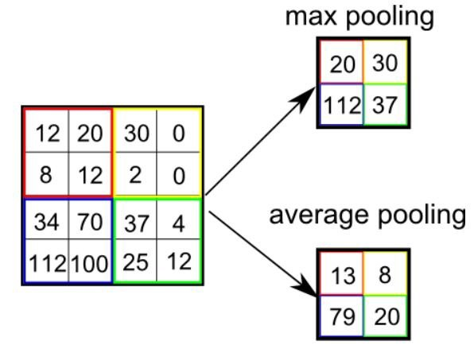

**Figure.5.2.2. Pooling Example for Diabetic Foot Ulcer**

**CHAPTER 6**

**SYSTEM IMPLEMENTATION**

**6.1. CODING**

from collections import OrderedDict

import pickle

from datetime import datetime

import requests

from flask import Flask, jsonify, request, redirect,render_template,url_for

import pandas as pd

import numpy as np

import os

import cv2

from PIL import Image, ImageDraw

from ast import literal_eval

import matplotlib.pyplot as plt

import urllib

from tqdm.notebook import tqdm

import glob

from PIL import Image,ImageOps

import os

import numpy as np

import pandas as pd

import tensorflow

import random

import cv2

from keras.models import Sequential

from keras.layers import Conv2D

from keras.layers import MaxPooling2D

from keras.layers import Dense

from keras.layers import Flatten

from tensorflow.keras.optimizers import SGD

import warnings

from keras import backend as K

from sklearn.model_selection import train_test_split

from PIL import Image

from keras.callbacks import EarlyStopping

from keras.layers import Dense, Activation, Dropout, Flatten,Conv2D, MaxPooling2D

from tensorflow.keras.layers import BatchNormalization

from sklearn.metrics import confusion_matrix

from keras.models import Model

from keras.layers import Dense, Conv2D, MaxPool2D , Flatten

from keras.models import load_model

import numpy as np

from flask import session

# Program to generate a random number between 0 and 9

# importing the random module

import random

from tensorflow.keras.models import Sequential

from tensorflow.keras.layers import Dense

def load_images_from_folder(folder):

images = []

dirs = os.listdir(folder)

for filename in dirs:

if os.path.isfile(folder+filename):

im = Image.open(folder+filename)

imResize = im.resize((224,224), Image.ANTIALIAS)

imResize = np.array(imResize)

if imResize is not None:

images.append(imResize)

return images

def prepareData(parentPath):

# Make a list of all the 0 label and 1 label images for train, val, and test sets

all0_path = list()

all1_path = list()

all0_path.append(parentPath+'/0/')

all1_path.append(parentPath+'/1/')

# Read images into respective lists

allX = list()

allY = list()

xTrain = list()

yTrain = list()

xVal = list()

yVal = list()

xTest = list()

yTest = list()

print('Class 0, reading started..\n\n')

tempImgs = list()

tempImgs = load_images_from_folder(all0_path[0])

for i in range(len(tempImgs)):

allX.append(tempImgs[i])

allY.append(0)

# Prepare all data for 1 class

print('Class 1, reading started..\n\n')

tempImgs = list()

tempImgs = load_images_from_folder(all1_path[0])

for i in range(len(tempImgs)):

allX.append(tempImgs[i])

allY.append(1)

xTrain,xTest,yTrain,yTest = train_test_split(allX,allY, test_size=0.20, random_state=23, shuffle = True)

xpTrain,xVal,ypTrain,yVal = train_test_split(xTrain,yTrain, test_size=0.10, random_state=23, shuffle = True)

return xpTrain, ypTrain, xVal, yVal, xTest, yTest

from keras.applications.inception_v3 import InceptionV3

def InceptionV3_transfer_actual(input_shape):

res = InceptionV3(weights=None, include_top=False, input_shape=input_shape)

for layers in res.layers:

layers.trainable = True

model = Sequential()

model.add(res)

model.add(Flatten())

## The following is the vanilla VGG16 architecture's FC layers

model.add(Dense(units=4096,activation="relu"))

model.add(Dense(units=4096,activation="relu"))

model.add(Dense(units=1000,activation="relu"))

model.add(Dense(units=1, activation="sigmoid"))

opt = SGD(lr=0.001, momentum=0.9)

model.compile(optimizer=opt, loss='binary_crossentropy', metrics=['accuracy'])

model.summary()

return model

img_width, img_height = 224, 224

input_shape = (img_width, img_height, 3)

model1 = InceptionV3_transfer_actual(input_shape)

model1.load_weights('inception_v3.h5')

labels=["Emphysema","Fibrosis","Ground Glass","nodules"]

app = Flask(__name__)

app.config['SESSION_TYPE'] = 'memcached'

app.config['SECRET_KEY'] = 'super secret key'

import pickle

**CLIENT-SIDE CODING**

from random import seed

from random import randint

#to generate seed number

seed(101)

@app.route('/')

def home():

return render_template('./index.html')

@app.route('/index')

def index():

return render_template('./index.html')

@app.route('/res')

def res():

return render_template('./result.html')

@app.route('/fileupload', methods=["GET", "POST"])

def fileupload():

imageurl = request.files['fileurl']

imageurl.save("1.jpg")

value = str(randint(0,90))+".jpg"

img = cv2.imread("1.jpg")

cv2.imwrite("static/images/"+str(value), img)

imResize = cv2.resize(img, (224, 224))

imResize = np.array(imResize)

normalize = imResize / 255

data=[]

data.append(normalize)

data.append(normalize)

data.append(normalize)

print(normalize.shape)

testPreds1 = model1.predict(np.asarray(data))

res="ulcer"

if(testPreds1[0]<=0.5):

res="Healthskin"

else:

res="Diabetic Food Ulcer"

return render_template('./result.html',val=value,res=res)

if __name__ == '__main__':

app.run(debug=False)

**CHAPTER 7**

**SYSTEM TESTING**

The purpose of the testing is to find errors. Testing is the process of trying to identify every possible flaw or weakness in the product. Provides a way to test the performance of parts, sub-assemblies, assemblies and / or finished product. It is a software application to ensure that the Software system meets its requirements and expectations of users and does not fail in an unacceptable way. There are different types of tests. Each type of test meets a specific test requirement.

**7.1. UNIT TESTING**

Unit testing involves the design of test conditions that ensure that the internal system intelligence works properly, and that system inputs produce valid output. All branches of decision and flow of internal code must be verified. Testing of each software unit of the apps .It is done after the completion of each unit before integration. This is a test of the structure, based on knowledge of its construction.

Unit testing performs basic tests at partial level and tests a specific business process, application, and / or system configuration. Unit testing ensures that each unique business process method operates precisely in the written specification and contains clearly defined inputs and expected outcomes.

**7.2. INTEGRATION TESTING**

Integration testing is designed to test integrated software components to determine if they really work as a single system. Experiments run the event and are very concerned about the basic effect of screens or fields. Integration tests show that although the components were individually satisfied, as evidenced by the success of the unit test, the component components are stable and stable. Integration tests are specifically designed to identify problems arising from compound parts.

**7.3. FUNCTIONAL TESTS**

Functional tests provide systematic demonstrations that functions tested are available as specified by the business and technical requirements, system documentation, and user manuals.

Functional testing is centered on the following items:

Valid Input : identified classes of valid input must be accepted.

Invalid Input : identified classes of invalid input must be rejected.

Functions : identified functions must be exercised.

Output : identified classes of application outputs must be exercised.

Systems/Procedures : interfacing systems or procedures must be invoked.

**7.4. TEST CASES AND RESULTS**

Field testing will be performed manually and functional tests will be written in detail.

**TEST OBJECTIVES**

* All field entries must work properly.
* Pages must be activated from the identified link.
* The entry screen, messages and responses must not be delayed.

**FEATURES TO BE TESTED**

* Verify that the entries are of the correct format
* No duplicate entries should be allowed
* All links should take the user to the correct page.

Software integration testing is the incremental integration testing of two or more integrated software components on a single platform to produce failures caused by interface defects.

The task of the integration test is to check that components or software applications, e.g. components in a software system or – one step up – software applications at the company level – interact without error.

**RESULT :**

All the test cases mentioned above passed successfully. No defects encountered.

**TEST CASE REPORT – 1**

**Product :** Detection of Diabetic Foot Ulcer

**Use case :** Home Page

**Table.7.4.1.Test Case table of home page for Diabetic Foot Ulcer**

|  |  |  |  |  |
| --- | --- | --- | --- | --- |
| **Test case ID** | **Test case /**  **Action to Perform** | **Expected Result** | **Actual Result** | **Pass / Fail** |
| 1. | Get the URL from idle and open it in the browser | Enters into the home page | Opens the Home Page in the browser | Pass |
| 2. | Choose trained image from folder | Extract the image from folder | Image gets extracted from folder and displayed in home page | Pass |
| 3. | File Upload | Enters into the detection page | Forwards to that particular diabetic foot ulcer detection page | Pass |

**TEST CASE REPORT – 2**

**Product :** Detection of Diabetic Foot Ulcer

**Use case :** Detection Result Page

**Table.7.4.2.Test Case table for Result of Detection page for Diabetic Foot Ulcer**

|  |  |  |  |  |
| --- | --- | --- | --- | --- |
| **Test case ID** | **Test case /**  **Action to Perform** | **Expected Result** | **Actual Result** | **Pass / Fail** |
| 1. | If the image is a healthy skin | Displays that the image is Healthy skin | Displays that the skin is Healthy and also the Percentage of skin infected. | Pass |
| 2. | If the image is a diabetic foot ulcer skin | Displays that the image is a Diabetic Foot ulcer skin | Displays that the skin is infected by the Diabetic Foot Ulcer and also the percentage of skin infected. | Pass |
| 3. | If the image is a wound | Displays that the image is a Healthy skin | Displays that the skin is healthy and not affected by Diabetic Foot Ulcer and also displays the percentage of skin infected. | Pass |

**CHAPTER 8**

**CONCLUSION**

**8.1.CONCLUSION AND FUTURE ENHANCEMENTS**

In this work, we have trained various dividers based on traditional machine learning algorithms, CNNs and proposed a CNN's architecture, DFUNet, focuses on diabetics ulcer on the feet. With high performance measures in classification, DFUNet allows DFU's accurate automatic detection of foot ulcer images and make it a new DFU method testing and treatment. This function lays the technical foundations that may change the acquisition once and for all treatment of ulcers on diabetic foot and led to paradigm changes in the care of a diabetic foot clinic.

This function has been created the basis for future gains which includes: 1) development of an automatic annotation that can be automatically defined and separate footimages without the assistance of nurses; 2) improve the detection of spontaneous lesions and detection as well segregation with the help of these classifier; 3) develop easy-to-use software tools including mobile wound applications recognition. Since DFUNet has worked well in dividing DFU, this proposed framework could be useful to separate other skin lesions such as the separation of sores, diseases such as chicken pox or shingles, other skin lesions such as moles and freckles, spots and pimples.

**8.2.APPENDICES**

* Open the command prompt to access the folder.
* Type idle to open the File and to get the URL for the web application.

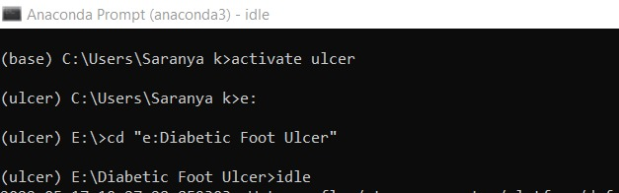

**Figure.8.2.1. Anaconda Prompt**

* Open the file that contains the code in the idle and Run the module.
* Once it is done, the idle displays an URL which must be copied and pasted to the browser to access the web application.

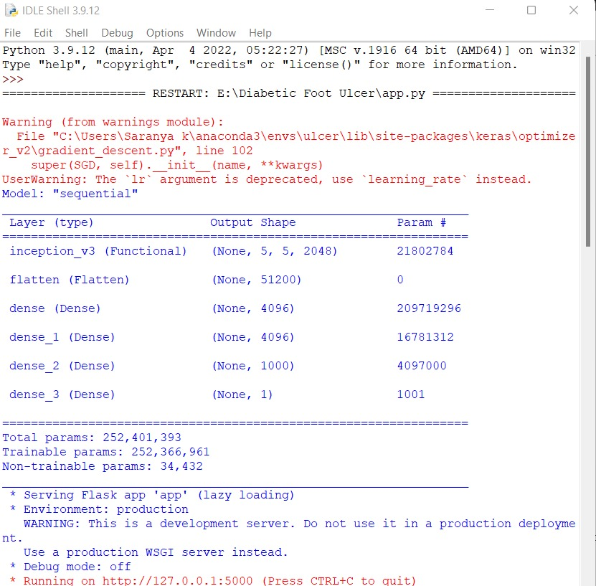

**Figure.8.2.2. Idle Shell**

* The home page gets displayed as follows.



**Figure.8.2.3. DFU Home Page**

* Choose the image from the Test data to detect the DFU.

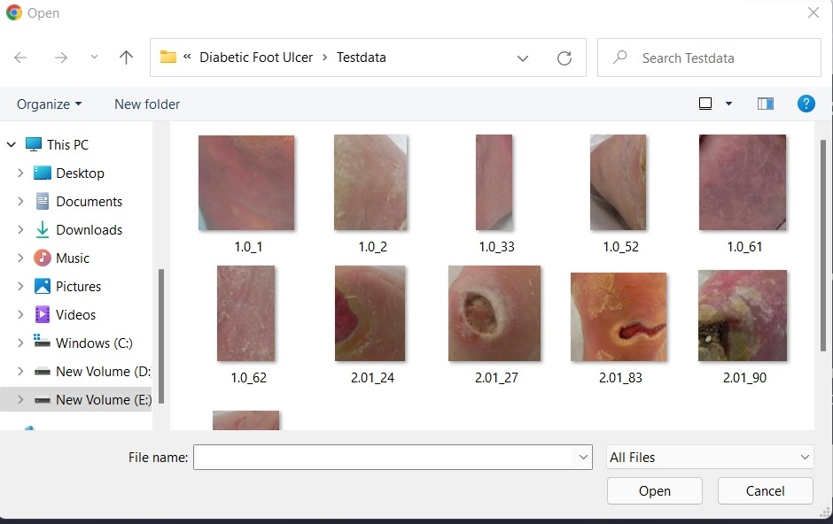

**Figure.8.2.4. Test images**

* The image is extracted from the folder and the result of detection is displayed.
* Here the skin is a healthy skin and it is also displayed with the percentage of skin infected.

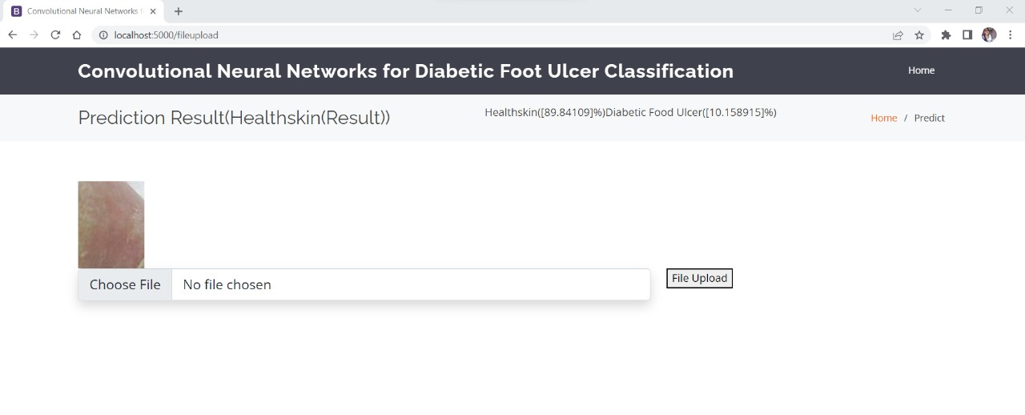

**Figure.8.2.5. Result of DFU Detection (Healthy Skin)**

* Here the image is the Diabetic Foot Ulcer skin and it also displays the percentage of skin infected.

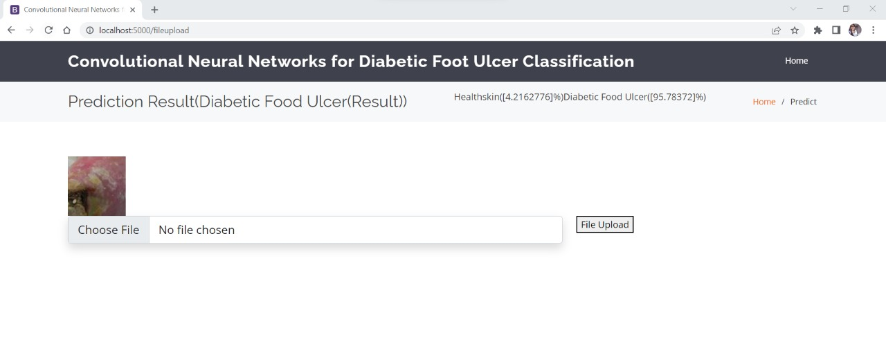

**Figure.8.2.6. Result of DFU Detection (Diabetic Foot Ulcer Skin)**

* The accuracy of the system is displayed as follows.

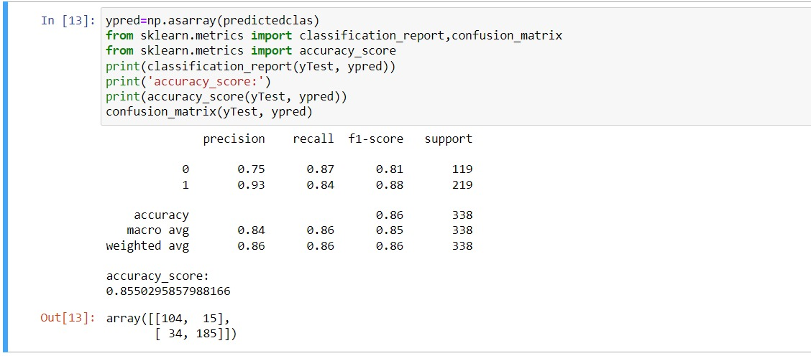

**Figure.8.2.7. Accuracy Calculation**

* The files in the Jupyter Notebook is displayed as follows.

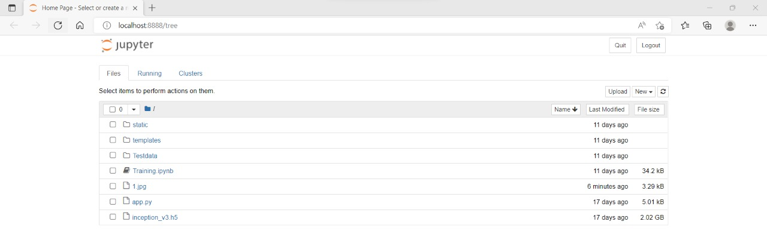

**Figure.8.2.8. Jupyter Notebook Files**

* The training code is displayed as follows.

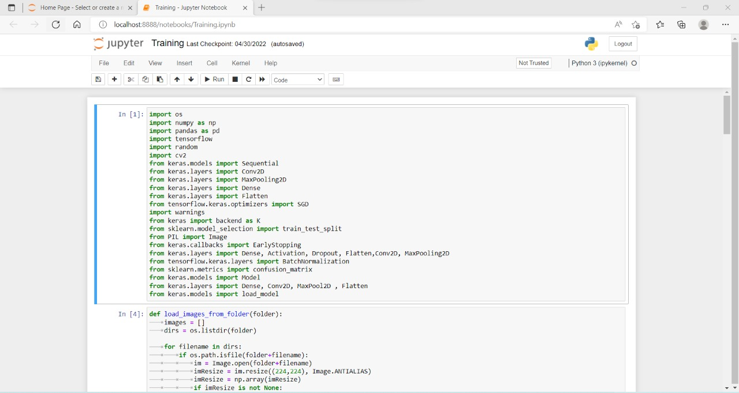

**Figure.8.2.9. Training code**

* The output array of the image convolutions is displayed as follows.

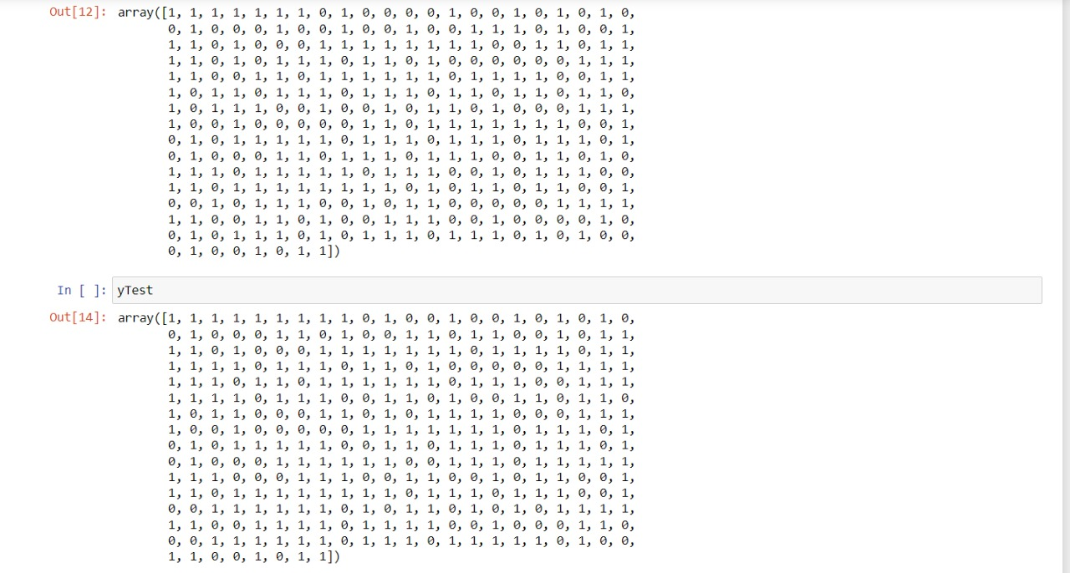

**Figure.8.2.10. Output Array**

**REFERENCE**

[1] Matilde Monteiro-Soares, Edward J. Boyko et.al “Diabetic foot ulcer classifications: A critical review” Wiley Online Library 16 March 2020

[2] Mayland Chang and Trung T. Nguyen “Strategy for Treatment of Infected Diabetic Foot Ulcers” **2021 American Chemical Society**

[3] Moi Hoon Yap a , Ryo Hachiuma et.al “Deep learning in diabetic foot ulcers detection: A comprehensive evaluation” Computers in Biology and Medicine (2021)

[4] Paola C. Aldana ,Amor Khachemoune et.al “Diabetic Foot Ulcers: Appraising Standard of Care and Reviewing New Trends in Management” American Journal of Clinical Dermatology 17 December 2019.

[5] Danielle Dixon, Michael Edmonds et.al “Managing Diabetic Foot Ulcers: Pharmacotherapy for Wound Healing” Springer Nature Switzerland AG 2020

[6] Dragos Serban, MD, PhD1, Nikolaos Papanas, MD, PhD et.al “Diabetic Retinopathy in Patients With Diabetic Foot Ulcer: A Systematic Review” The International Journal of Lower Extremity Wounds 2020

[7] Morica M. Tran and Melanie N. Haley “Does exercise improve healing of diabetic foot ulcers? A systematic review” Journal of Foot and Ankle Research (2021)

[8] C. E. Hazenberg, J. J. van Netten, S. G. van Baal, and S. A. Bus, “Assessment of signs of foot infection in diabetes patients using photographic foot imaging and infrared thermography,” Diabetes technology & therapeutics, vol. 16, no. 6, pp. 370–377, 2014

[9] P. Foltynski, J. M. Wojcicki, P. Ladyzynski, K. Migalska-Musial, G. Rosinski, J. Krzymien, and W. Karnafel, “Monitoring of diabetic foot syndrome treatment: some new perspectives,” Artificial organs, vol. 35, no. 2, pp. 176–182, 2011

[10] C. Liu, J. J. van Netten, J. G. Van Baal, S. A. Bus, and F. van Der Heijden, “Automatic detection of diabetic foot complications with infrared thermography by asymmetric analysis,” Journal of biomedical optics, vol. 20, no. 2, pp. 026 003–026 003, 2015.

[11] L. Wang, P. C. Pedersen, D. M. Strong, B. Tulu, E. Agu, R. Ignotz, and Q. He, ‘‘An automatic assessment system of diabetic foot ulcers based on wound area determination, color segmentation, and healing score evaluation,’’ J. Diabetes Sci. Technol., vol. 10, no. 2, pp. 421–428, Mar. 2016

[12] D. Coppini, ‘‘New NICE guidelines on diabetic foot disease prevention and management,’’ Practical Diabetes, vol. 32, no. 8, p. 286, 2015

[13] I. Kavakiotis, O. Tsave, A. Salifoglou, N. Maglaveras, I. Vlahavas, and I. Chouvarda, ‘‘Machine learning and data mining methods in diabetes research,’’ Comput. Struct. Biotechnol. J., vol. 15, pp. 104–116, 2017.

[14] Liu, C., van Netten, J. J., Van Baal, J. G., Bus, S. A., and van Der Heijden, F. (2015). Automatic detection of diabetic foot complications with infrared thermography by asymmetric analysis. Journal of biomedical optics, 20(2):026003

[15] L. Wang et al., “Wound image analysis system for diabetics,” Int. Soc. Opt. Photonics, vol. 8669, p. 866924, 2013.

[16] Armstrong DG, Boulton AJ, Bus SA. Diabetic foot ulcers and their recurrence. N Engl J Med. 2017;376(24):2367-2375

[17] Fife CE, Horn SD, Smout RJ, Barrett RS, Thomson B. A predictive model for diabetic foot ulcer outcome: the Wound Healing Index. Adv Wound Care. 2016

[18] R. Brüngel, C.M. Friedrich, DETR and YOLOv5: exploring performance and selftraining for diabetic foot ulcer detection, in: 2021 IEEE 34th International Symposium on Computer-Based Medical Systems (CBMS), IEEE, 2021, pp. 148–153